**PYTHON TASKS**

**NAME: ADVITEEYA SHRAV EMP. NO: 50044549/113830**

1. Write a Program for the following Requirement

Input: a4b3c2

Output: aaaabbbcc

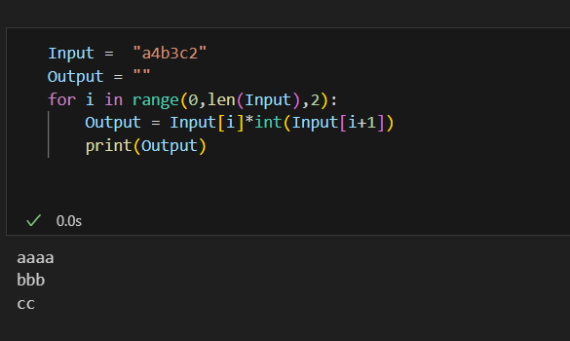

2. Write a Program to Remove Duplicate Characters from the given Input String?

Input: ABCDABBCDABBBCCCDDEEEF

Output: ABCDEF

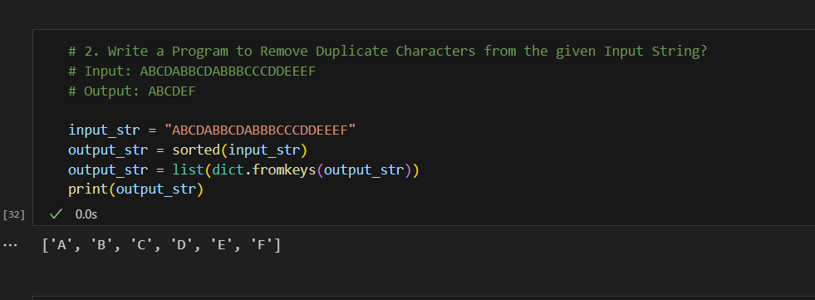

3. Write a Program to find the Number of Occurrences of each Character present in the given String?

Input: ABCABCABBCDE

Output: A-3,B-4,C-3,D-1,E-1

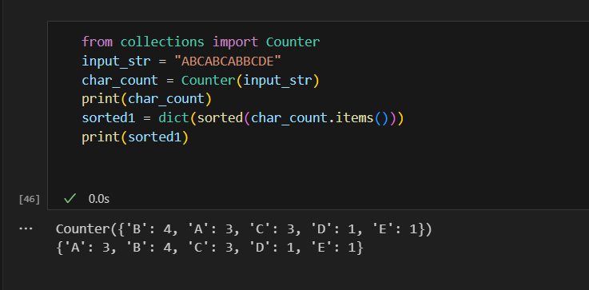

4. Write a Program to perform the following Task?

Input: 'one two three four five six seven'

Output: 'one owt three ruof five xis seven'

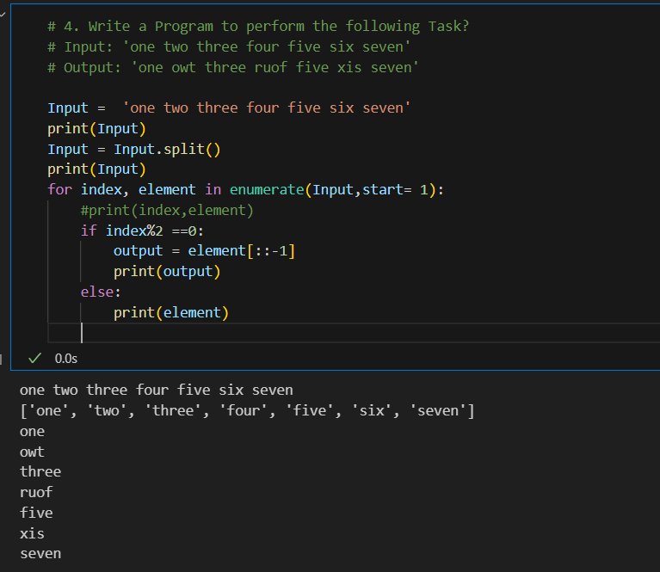

5. Write a Program to display Unique Vowels present in the given Word?

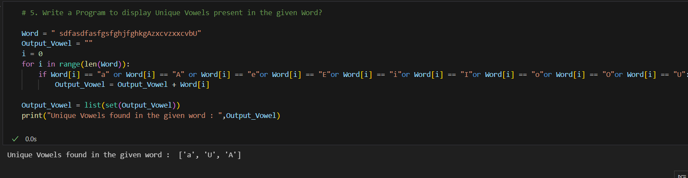

6. Write a Program to take Dictionary from the Keyboard and print the Sum of Values?

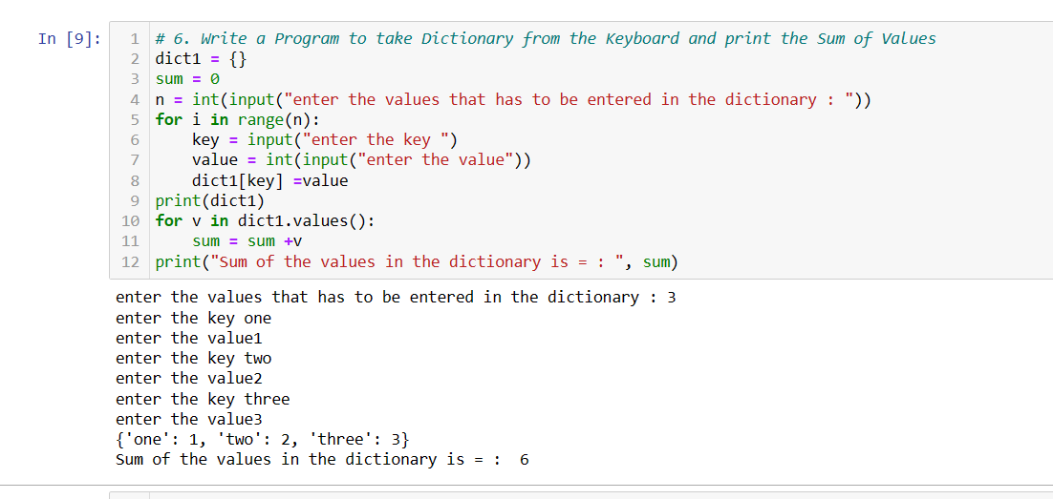

7. Write a Program to find Number of Occurrences of each Letter present in the given String?

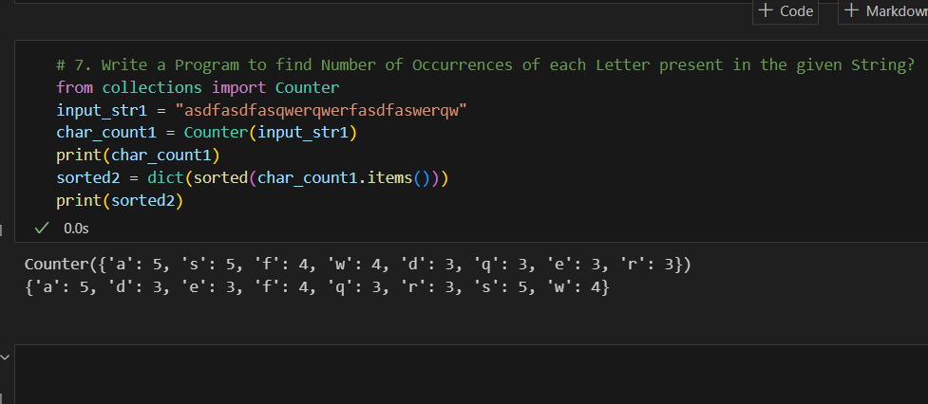

8. Write a Program to find Number of Occurrences of each Vowel present in the given String?

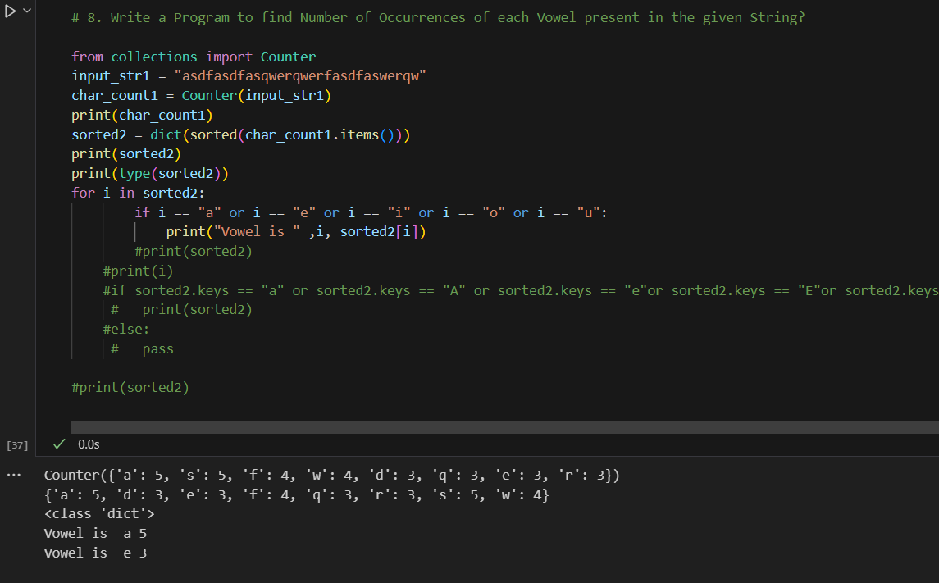

9. Write a Program to accept Student Name and Marks from the Keyboard and creates a Dictionary. Also display Student Marks by taking Student Name as Input?

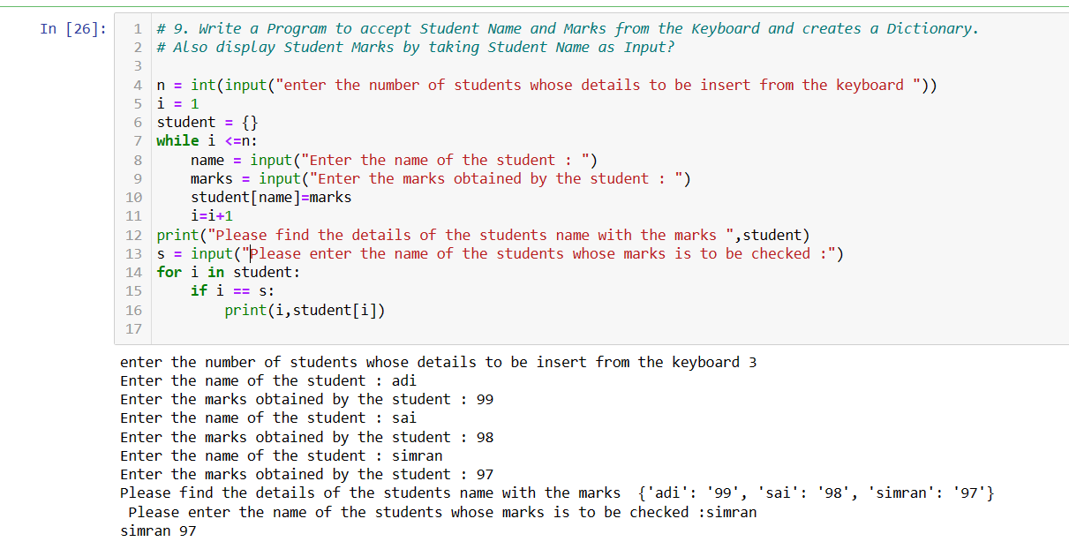

10. Write a Program to print table of any number till 20, accepting number at run time.

